Basildon |  |  |  |  |  |  |  |  |  |  | Braintree
 |  |  |  | 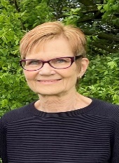 |  |  | 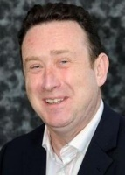 |  |  |  |  |  | 
Kerry  Smith  Basildon Westley Heights | Anthony Hedley  Billericay and Burstead |  | Richard Moore  Billericay and Burstead | Patricia  Reid  Laindon Park and Fryerns | Jeff  Henry  Laindon Park and Fryerns | Emma Callaghan  Pitsea | Aidan  McGurran  Pitsea |  | Tony  Ball  Wickford Crouch | Malcolm Buckley  Wickford Crouch | Lynette Bowers-Flint  Bocking |  | Paul Thorogood  Braintree Eastern
 | 2 Member Division |  |  | 2 Member Division |  | 2 Member Division |  |  | 2 Member Division
Braintree (cont) |  |  |  |  |  |  |   Brentwood
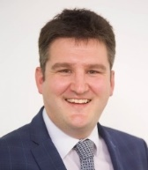 |  |  | 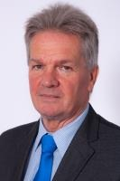 | 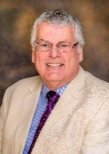 |  |  |  |  |  | 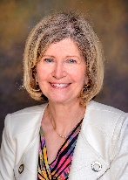 | 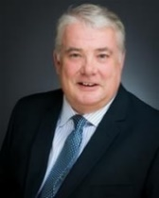
Tom Cunningham  Braintree Town | Chris  Siddall  Halstead |  | Peter  Schwier  Hedingham | Graham Butland  Three Fields with Great Notley | Ross  Playle  Witham Northern | Derrick Louis  Witham Southern | Louise McKinlay  Brentwood Hutton |  | Barry  Aspinell  Brentwood North | Lesley Wagland  Brentwood Rural | Andrew  Wiles  Brentwood South
Castle Point |  |  |  |  |  | Chelmsford
 |  |  |  |  | 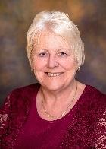 | 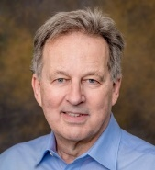 | 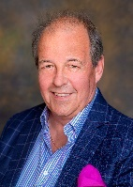 |  |  |  |  |  | 
Dave Blackwell  Canvey Island East | Peter  May  Canvey Island West |  | Jillian Reeves  Hadleigh | Andrew Sheldon  South Benfleet | Beverley Egan  Thundersley | Mike  Steel  Broomfield and Writtle | John  Spence  Chelmer |  | David Loxton  Chelmsford Central | Stephen Robinson  Chelmsford North | Jude  Deakin  Chelmsford West |  | Anthony  McQuiggan  Great Baddow
Chelmsford (cont) |  |  |  | Colchester
 |  |  | 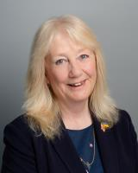 |  | 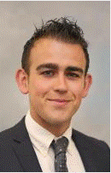 |  | 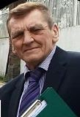 |  |  |  |  |  | 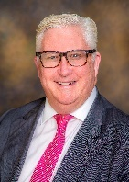
Bob  Massey  South Woodham Ferrers | Michael Mackrory  Springfield |  | Sue Dobson  Stock | Lee  Scordis  Abbey | Lewis  Barber  Constable | Sue Lissimore  Drury | Dave  Harris  Maypole |  | John Jowers  Mersea and Tiptree | David  King  Mile End and Highwoods | Simon  Crow  Parsons Heath and East Gates |  | Kevin Bentley  Stanway and Pyefleet
Colchester (cont) | Epping Forest |  |  |  |  |  |  |  |  | Harlow
 | 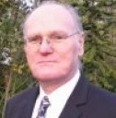 |  | 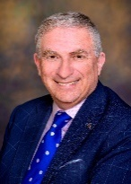 | 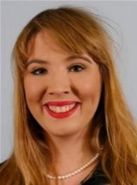 |  | 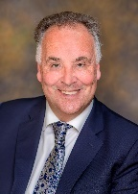 |  |  | 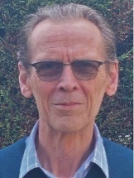 |  | 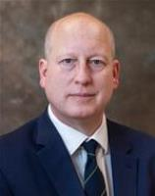 | 
Mark  Cory  Wivenhoe  St Andrew | Marshall  Vance  Buckhurst Hill and Loughton South |  | Lee  Scott  Chigwell and Loughton Broadway | Holly Whitbread  Epping and Theydon Bois | Chris  Pond  Loughton Central | Christopher Whitbread  North Weald  and Nazeing | Jaymey  McIvor  Ongar and Rural |  | Simon  Kane  Waltham Abbey | Mike  Garnett  Harlow North | Andrew Johnson  Harlow South East | Michael Hardware  Harlow West
 |  |  |  |  |  |  |  |  |  |  |  | 2 Member Division
Harlow (cont) | Maldon |  |  |  | Rochford |  |  |  |  |  | Tendring
 |  |  |  | 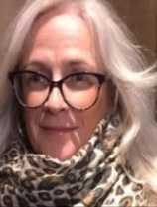 | 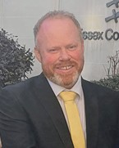 |  | 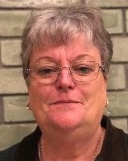 |  |  |  |  | 
Clive  Souter  Harlow West | Mark Durham  Heybridge And  Tollesbury |  | Jane Fleming  Maldon | Wendy  Stamp  Southminster | James Newport  Rayleigh North | June  Lumley  Rayleigh South | Laureen  Shaw  Rochford North |  | Mike Steptoe  Rochford South | Michael  Hoy  Rochford  West | Alan  Goggin  Brightlingsea | Mark Stephenson  Clacton East
2 Member Division
Tendring (cont) |  |  |  |  |  |  | Uttlesford
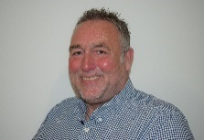 |  |  |  |  |  |  |  |  | 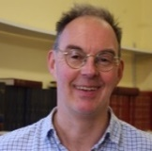 |  | 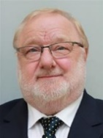
Michael  Skeels  Clacton North | Paul Honeywood  Clacton West |  | Mark  Platt  Frinton and Walton | Ivan Henderson  Harwich | Daniel  Land  Tendring Rural East | Carlo Guglielmi  Tendring Rural West | Susan Barker  Dunmow |  | Paul  Gadd  Saffron Walden | Raymond Gooding  Stansted | Martin  Foley  Thaxted

